Complete View Returns process
Ceci fonctionne que sur le navigateur Chrome
This is to be used for the transfer of product from Emergency Centres, Reps to hospitals/clinics or hospitals to hospitals with an urgent requirement for product not available from stock in EMEA DC warehouse.
Please ensure that the following 4 sections are filled in.

Please use the following link https://row.ups.com/Membership/Login/Login
Log in details
Alias Cook
New User: Cook-user
Password: Cook-user1
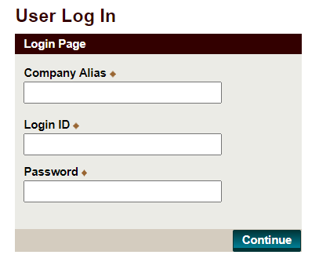
- Ship From
If shipping from the Emergency Rep Stock centres, we have pre-populated the ERS centre addresses. You can select your relevant centre and the address will automatically show up.
Otherwise, follow the guidelines below:
- Enter all the address details
- Make sure to entre the relevant contact person in the field “Attention”
- Select the country from the drop down list
- Enter the phone number and email adress of your contact
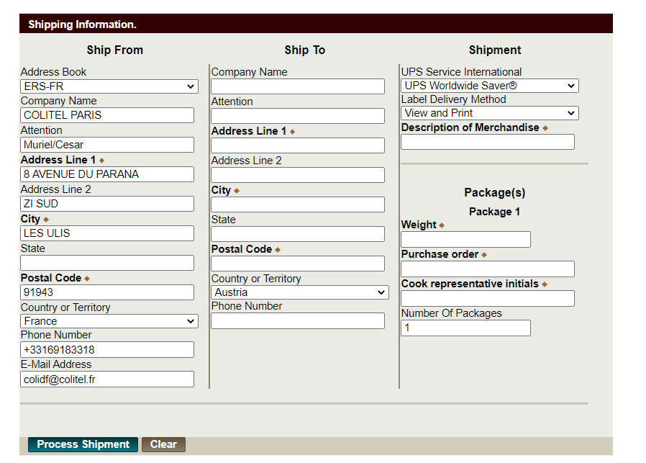
- Ship To

- Enter all the address details
- Make sure to entre the relevant contact person in the field “Attention”
- Select the country from the drop down list
- Enter the phone number and email adress of your contact

- Shipment

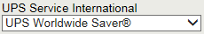

1. The default Service Level is set to Express Saver Service.
2. As this service is for Emergencies, you have the option to select Express Plus or Express from the drop down.

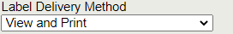

You can choose two different options:
- View and print – this option prints an electronic AWB# which you can print and attach. If the product is shipping from a customer to another, please be sure that your customer can print the label and put it on the box (this option will allow you to request a scheduled pickup after you click on “Process Shipment”).
- 3 UPS On-call Pickup Atpt – UPS will print and collect the box at the address provided

- Package(s)
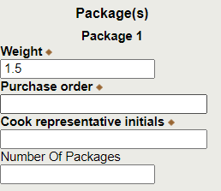
-Weight: Always input 1.5kg
-Purchase order: enter the original SO number and add the lot number(s) of the product(s) being transferred (i.e. 19499.649 lot number 13873638)
-Cook Representative initials: add your own initials
-Number of packages: enter many packages as you have to ship.

NB: Si vous allez directement chez UPS notre compte est le W1192R .

